C2- S13 REVISIONS

# CORRECTION

**Exercise 1:**

The alphabet is given below to help you:

a b c d e f g h i j k l m n o p q r s t u v w x y z

**Q1** a w b s c o

**Q2** e e z j j y o o x t t w y y

**Exercise 2:**

|  |  |
| --- | --- |
|  |  |
| **Q1** | An ASCII represents 245 characters. What is the size (in bits) of an ASCII? *(Justify your answer)* |
|  | 245 = 11110101 that have 8bits |
|  | So, 245 characters need size 8 bits |
| **Q2** | with 8 bytes, how many values can be represented? *(Justify your answer)*  *3bytes = 8x8bits = 64bits* |
|  | *Have 264values can be represented.* |
| **Q3** | How many bits to store alphabet and number in keyboard 0…9, A…Z and a…z |
|  |  |
|  | 0…9 have 10 values |
|  | A…Z have 26 values |
|  | a…z have 26 values |
|  | Total of number 10 + 26 + 26 = 62 |
|  | 0bit = 20= 1 values |
|  | 1bit = 21= 2 values  2bits = 22= 4 values  3bits = 23= 8 values  4bits = 24= 16 values  5bits = 25= 32 values  6bits= 26= 64 values |
|  |  |

So, we 6bits to store.

**Exercise 3:**

|  |  |
| --- | --- |
|  |  |
| **Q1** | What is the result of this operation with binary numbers?  1011 0101  - 0101 1110 |
|  | The answer is **1010111** |
| **Q2** | What is the result of this operation with binary numbers?  1111 0011   * 0111 1101 * 0011 1011 |
|  | The answer is **111011** |
| **Q3** | What is the result of this operation with binary numbers?  1011 0011   * 0101 1101 * 0011 1011 * 0001 1000 |
|  | The answer is **11** |
| **Q4** | What is the result of this operation with binary numbers?  1011 0101  + 0111 1111 |
|  | The answer is **100110100** |
| **Q5** | What is the result of this operation with binary numbers? |

1111 0011

+ 1001 1101

+ 0111 1011

The answer is **1000001011**

**Q6** What is the result of this operation with hexadecimal numbers?

D2F7

+ CF84 + 3CDE

The answer is **1DF59**

**Exercise 4:**

Compute the following conversions

|  |  |
| --- | --- |
| Base 2 | Base 10 |
| 101101 | *Explanation:*  101101=32+0+8+4+0+1=45 |

|  |  |
| --- | --- |
| Base 2 | Base 16 |
| 101101 | *Explanation:*  1101 = D  10 =2  So, 101101 = 2D |

|  |  |
| --- | --- |
| Base 16 | Base 8 |
| D8F | *Explanation*  Base16->Base2  D8F= 110110001111    Base2->Base8  110110001111= 6617base8  So D8F=6617 |

|  |  |
| --- | --- |
| Base 16 | Base 2 |
| D8F | *Explanation*:  D=1101  8=1000  F=1111  So D8F=110110001111 |

**Exercise 5:**

**Q1. Rules:**

• 3 characters “AOU”, repeated many times (min repetition is 1 , max repetition is 10) • In the end you can have X, Y or Z, only one letter

Examples:

AOUAOUX

AOUY

AOUAOUAOUAOUX

1. Explain your encoding

|  |  |  |
| --- | --- | --- |
| Meaning | Encoding in decimal | Encoding in binary |
| Number of repetition of the  text AOU    Example : 4 will produce  AOU AOU AOU AOU | 1  To  10 | 0001  To  1010 |
| The characters at the end | 0: X  1: Y 2: Z | 00  01  10 |

1. Give examples

0001 10 = AOUZ

1. Explain the size : 101010 = 6bits

**Q2. Rules:**

* + 3 signs: @, #, %
  + The signs can be displayed in any order
  + Each sign is repeated from 0 to 5 times
  + In the end you can have A, B or C, only one letter

Examples:

@@###A

%%@@@@@#B

######C

1. Explain your encoding, give the example and your explanation

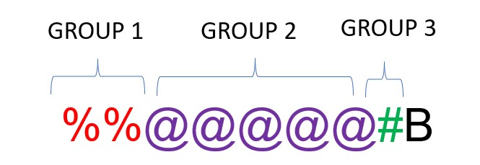

|  |  |  |
| --- | --- | --- |
| Meaning | Encoding in decimal | Encoding in binary |
| GROUP 1 |  |  |
| Character | 1. @ 2. # 3. % | 00  01  10 |
| Repetition | 0  To  5 | 000  To  101 |
| GROUP 2 |  |  |
| Character | 1. @ 2. # 3. % | 00  01  10 |
| Repetition | 0  To  5 | 000  To  101 |
| GROUP 3 |  |  |
| Character | 1. @ 2. # 3. % | 00  01  10 |
| Repetition | 0  To  5 | 000  To  101 |
| LAST CHARACTER |  |  |
| Last Character | 1. A 2. B 3. C | 00  01  10 |

1. For this example, **%%%%%**C, what is the littlest size possible with your encoding?

%%%%%C = 10 101 10 = 7bits

1. Explain the size

@@@@@#####%%%%%C = 00 101 01 101 10 101 10 = 17bits

## EXERCICE 6: Encoding problem

**Rules:**

* 4 letters: A, B, C, D
* Any order
* Max text length = 14

Examples:

ABCDDDDDDD

DBCAA

ADABCAA

g) Explain your encoding

SOLUTION 1

|  |  |  |
| --- | --- | --- |
| Meaning | Encoding in decimal | Encoding in binary |
| We repeat this as needed: |  |  |
| Character | 1. A 2. B 3. C 4. D | 1. A 2. B 10 C   11 D |

Example

ADABCAA

00 11 00 01 10 00 00

SOLUTION 2

|  |  |  |
| --- | --- | --- |
| Meaning | Encoding in decimal | Encoding in binary |
| We repeat this as needed: |  |  |
| Character | 1. A 2. B 3. C 4. D | 1. A 2. B 10 C   11 D |
| Repetition | 0 to 14 | 0000 to  1110 |

Example

ADABCAA

00 0001 11 0001 01 0001 10 0001 00 0010

## EXERCICE 7: Encoding problem

**Rules**:

* First 2 characters “AB”, repeated many times (max repetition is 5)
* Then 1 character “*”, repeated many times (max repetition is 5)
* Then 1 number (0-9)

Examples:

ABABAB***8

AB*****7

ABABAB*****3

1. Explain your encoding

|  |  |  |
| --- | --- | --- |
| Meaning | Encoding in decimal | Encoding in binary |
| Number of repetition of the text **AB** | 1…5 | 001…101 |
| Number of repetition of the text **\*** | 1…5 | 001…101 |
| Have one number at the end | 1…9 | 0001…1001 |

1. Give examples

ABABAB**7 = 001 010 0111

1. Explain the size

ABABABABAB*****9 =101 101 1001 = 10bits

## EXERCICE 8: Encoding problem

**Rules:**

* 4 letters: A, E, O, U
* Each letter is repeated minimum 0 time and maximum 7 times.
* The letters are always in the alphabetic order: A then E then O then U

Examples:

AAAAEEEOOU

EEEUUUUUUU

AAEEOOUU

1. Find an encoding of maximum **12 bits**. Explain the method, explain the size and give examples.

|  |  |  |
| --- | --- | --- |
| Meaning | Encoding in decimal | Encoding in binary |
| Number of repetition of the  Letter **A** | 0…7 | 000…111 |
| Number of repetition of the  Letter E | 0…7 | 000…111 |
| Number of repetition of the  Letter O | 0…7 | 000…111 |
| Number of repetition of the  Letter U | 0…7 | 000…111 |

AAAAAAAEEEEEEEOOOOOOOUUUUUUU= 111 111 111 111

1. Is your encoding lossless or loosely?

It is lossless because (000 000 001 010 = OUU)

## 9: Encoding problem

**Rules:**

• The image has only 2 options A & B

Question - Find an encoding

|  |  |  |
| --- | --- | --- |
| Meaning | Encoding in decimal | Encoding in binary |
| Position of Black Color. | 0: one black at first and two black and last  1:two black at first and one black at last | 0  1 |

## 10: Encoding problem

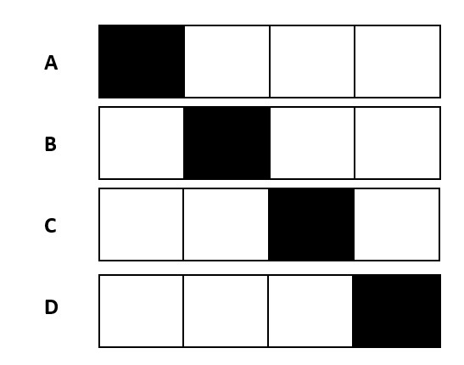

**Rules:**

• The image has only 4 options A, B, C, D

Question - Find an encoding

|  |  |  |
| --- | --- | --- |
| Meaning | Encoding in decimal | Encoding in binary |
| Position of Image | 1. : The black is the 1st pixel 2. : The black is the 2nd pixel   2: The black is the 3rd pixel  3: The black is the 4th pixel | 00  01  10  11 |

## 10: Encoding problem

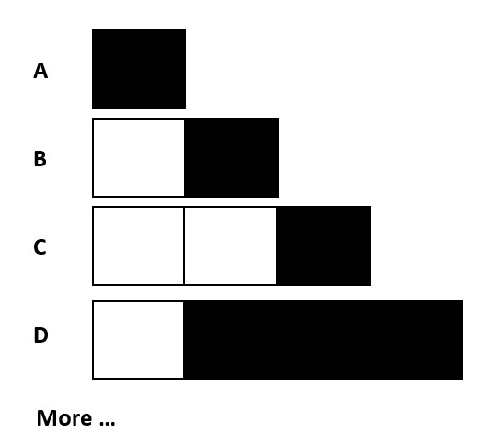

**Rules:**

* The image has 1 to 4 pixels
* 1 to 3 black pixels
* The black pixels shall be together

Question - Find an encoding

|  |  |  |
| --- | --- | --- |
| Meaning | Encoding in decimal | Encoding in binary |
| Width of Image | 1…4 | 001…100 |
| Position of black color | 1…4 | 001…100 |
| Number of black color | 1…3 | 01…11 |

## 11: Encoding problem

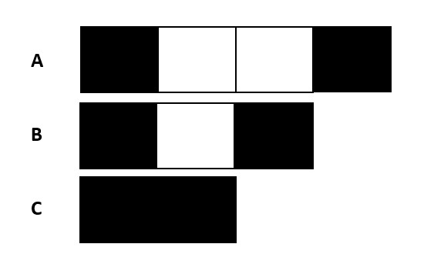

**Rules:**

* Pixels can be white or back
* The image size can be from 2 to 4 pixel
* The white pixels have 0 to 2
* Black pixel always first and last cells

Question - Find an encoding

|  |  |  |
| --- | --- | --- |
| Meaning | Encoding in decimal | Encoding in binary |
| Width of Pixel | 2..4 | 010…100 |